Diamond SC, NC and Bo Cavities LLRF –Control Specs V2
Version | Date | Description
V0 | 28th Oct 2015 | First Draft - controls for SC Cavities
V1 | 26th May 2016 | Controls for three different cavity types added: Normal Conducting, Superconducting and Booster Cavity
V2 | 26th July 2016 | GUI Specs added

Introduction
The EPICS Device Server or Server IOC should be in charge of exchanging information between the Perseus Boards and the Graphical User Interface.
Nutaq provides two different ways of accessing and configure the Perseus and FMC Boards through the Linux Host PC installed in the same chassis than the Nutaq boards:
- Command Line Interface (CLI): python script that provides a command shell to configure FMC and Carrier
- EAPI: Interface based on C++ libraries
In this document, the basic commands to access, program and configure the LLRF system will be described based on the CLI interface.
For the complete list of commands and attributes that can be modified through the “CLI” interface, please refer to the “Programmers Reference Guide Command Line Inerface.pdf”:
..\..\..\..\..\..\Nutaq\ADP6\ADP_MicroTCA\documentation\pdf\API\Programmer's Reference Guide Command Line Interface.pdf
For the complete list of functions available in the EAPI, please refer to the “Nutaq MicroTCA BSDK API”
..\..\..\..\..\..\Nutaq\ADP6\ADP_MicroTCA\documentation\pdf\API\microtca_bsdk_api.pdf

LLRF initialization

Connection to Perseus Boards through CLI Interface
To start this Command Line Interface, the user should follow next steps:
- Open a terminal in the Linux Host PC
- Browse to the CLI folder: /opt/Nutaq/ADP6/ADP_MicroTCA/sdk/bin
- Run the CLI script as super user: sudo ./adp_cli.py
- Establish connection with the Perseus Board with the command “connect” and the IP address of the board. Example: connect 192.168.0.101

Initialization of Nutaq boards
As soon as the uTCA Linux CPU is started, the Device Server (DS) or Server IOC controlling the LLRF should start automatically and the initialization process of the Perseus boards should be done. The initialization process consists of:
- Configuration of clock and the internal PLL of the Perseus Board
- Configuration and calibration of the DACs of the MO1000 board of the Perseus System
- Configuration of the ADCs of the MI125 board of the Perseus System
- Configuration of the GPIO bus of the Mestor Breakout Box of Perseus System
- Configuration of the VCXO/PLL of the Loops Front End
- Cavity type configuration: Normal conducting, super conducting or Booster cavity
Table 1 shows the commands to configure Perseus Board with one MO1000 and one MI125 FMC boards
Initialization commands of Perseus Loops Board | Comments
custom_register_write 4 1  mo1000_powerup 1  mo1000_reset 1  mo1000_init 1  mo1000_setdacparinterpolation 1 1x  mo1000_dodacupdate 1  mo1000_setclockconfig 1 Ext 80000000 80000000 Manual 80000000  mo1000_writeclockconfig 1  mo1000_dodaccalibration 1  mo1000_setdacoutctrl 1 1 Enable  mo1000_setdacoutctrl 1 2 Enable  mo1000_setdacoutctrl 1 3 Enable  mo1000_setdacoutctrl 1 4 Enable  mo1000_setdacoutctrl 1 5 Enable  mo1000_setdacoutctrl 1 6 Enable  mo1000_setdacoutctrl 1 7 Enable  mo1000_setdacoutctrl 1 8 Enable  mo1000_gettemperature 1 temp1c  mi125_powerup 2  mi125_reset 2  mi125_set_clksrc 2 BOTTOMFMC  mi125_get_temperature 2 TEMP1C  custom_register_write 4 0 | Command to reset Asyn FIFO of DACs  Clock source: External and set to 80MHz  Removal of reset of async FIFO of DACs
Table 1.-Initialization commands of Perseus Loops Board
Following tables show the whole available commands to configure the FMC boards of the LLRF: MO1000 FMC Board (DACs board) and MI125 FMC Board (ADCs board)
Command | Argument | Description | Example
mo1000_powerup | - ID of the MO1000 (1 or 2) | Powers up a MO1000 FMC | mo1000_powerup 1
mo1000_reset | - ID of the MO1000 (1 or 2) | Resets a MO1000 to its default non operating condition | mo1000_reset 1
mo1000_init | - ID of the MO1000 (1 or 2) | Initializes a MO1000 to its default operating condition | mo1000_init 1
mo1000_getstatus | - ID of the MO1000 (1 or 2) | Gets MO1000 board status and pattern test errors | mo1000_getstatus 1
mo1000_gettemperature | - ID of the MO1000 (1 or 2)  - Output format | Gets board PCB and DACs temperatures | mo1000_gettemperature 1 temp1c
mo1000_getchannelcalibstatus | - ID of the MO1000 (1 or 2) | Gets MO1000 board calibration status | mo1000_getchannelcalibstatus 1
mo1000_dodaccalibration | - ID of the MO1000 (1 or 2) | Performs a MO1000 calibration | mo1000_dodaccalibration 1
mo1000_setdacoutctrl | - ID of the MO1000 (1 or 2)  - DAC channel ([1,8])  - DAC output state | Controls the DAC output state for the specified channel | mo1000_setdacoutctrl 1 1 enable
mo1000_setclockconfig | - ID of the MO1000 (1 or 2)  - Clock source  - Source clock frequency (if clock source is not 125MHz)  - DAC clock desired frequency  - Master clock mode  - Master clock frequency (if clock mode is manual) | Sets up the clocks of the module | mo1000_setclockconfig 1 125mhz 0 250000000 auto 0
mo1000_writeclockconfig | - ID of the MO1000 (1 or 2) | Writes the module clocks setup prepared with mo1000_setclockconfig | mo1000_writeclockconfig 1
mo1000_getpllconfig | - ID of the MO1000 (1 or 2) | Gets the module PLL parameters prepared with mo1000_setclockconfig | mo1000_getpllconfig 1
Table 2.- MO1000 CLI commands
Command | Argument | Description | Example
mi125_reset | - MI125 target board (1) | Resets and initializes the MI125 (ADC, clock routing, all options...) with default values. | Mi125_reset 1
mi125_powerup | - MI125 target board (1) | Powers up the MI125 board. | mi125_powerup 1
mi125_digital_adccalibration | - MI125 target board (1) | Forces the ADC output digital calibration. | mi125_digital_adccalibration 1
mi125_set_config | - MI125 target board (1)  - Channel group  - ADC output LVDS  - ADC output randomize mode  - ADC output data format | Configures board options. | mi125_set_config 1 16channels termon1750ua randomizeoff twocomplement
mi125_set_clksrc | - MI125 target board (1)  - Clock source (125 MHz,EXT, BOTTOMFMC,FMCCARRIER) | Configures ADC clock source | mi125_set_clksrc 1 125mhz
mi125_checkcore | - MI125 target board (1) | Checks for the MI125 FPGA core presence. | mi125_checkcore 1
mi125_set_testmode | - MI125 target board (1)  - Testmode (TESTMODEOFF, TESTMODE1, TESTMODE2)  - Pattern | Configures the ADC test mode or not. In test mode, the digital interface will continuously send the programmed pattern. | mi125_set_testmode 1 testmode2 0x33CC
mi125_get_temperature | - MI125 target board (1)  - Temperature data output format to use (TEMP1C, TEMP0DOT1C) | Gets the PCB temperature. | mi125_get_temperature 1 temp1c
mi125_get_channelcalibstatus | - MI125 target board (1) | Gets the ADC last digital calibration status. | mi125_get_channelcalibstatus 1
mi125_get_versions | - MI125 target board (1) | Gets the FPGA core and firmware version of the board. | mi125_get_versions 1
mi125_checkadc | - MI125 target board (1)  - ADC id to verify (ADCX, x = 0 to 3) | Runs the ADC check. | mi125_checkadc 1 ADC0
mi125_set_trigout | - MI125 target board (1)  - Trigger output configuration (TRIGOUTON, TRIGOUTOFF) | Configures the MI125 trigger output. | mi125_set_trigout 1 trigoutoff
mi125_get_clkmaster | - MI125 target board (1) | Gets if the module is a clock master. | mi125_get_clkmaster 1
mi125_clockreset | - MI125 target board (1) | Forces an MCM clock reset. | mi125_clockreset 1
Table 3.- MI125 CLI Commands

User-defined custom registers
Besides the general functions developed by Nutaq to configure the hardware of the FMC mezzanines, the Perseus boards have 32 user-defined custom registers that can be used to write/read data into/from FPGA. Each of these registers allows writing/reading words of 32 bits and they have been configured to write/read the settings of the LLRF and also the diagnostic signals displayed in the LLRF GUI.
Table 4 shows the offset address of the user-defined registers that have been used for LLRF adjustments. These offset addresses are the same ones for the Loops Board than for the Diagnostics Board.
User-define register | Offset address | LLRF use
Register 10 | 0x70000040 | LLRF Settings Write
Register 11 | 0x70000044 | LLRF Settings Read-back
Register 12 | 0x70000048 | LLRF Diagnostics
Register 13 | 0x7000004C | GPIO Bus Configuration – write settings
Register 14 | 0x70000050 | Read-back of GPIO Bus Configuration and read-back of slow ADCS of Mestor Breakout Boxes
Register 15 | 0x70000054 | Cavity Type selection: ‘0’ or ‘1’ for Normal conducting cavities, ‘2’ for Super Conducting cavities, ‘3’ for Booster Cavity
Register 31 | 0x70000094 | FPGA version read-back
Table 4.- User-defined custom registers used for Settings and Diagnostics of LLRF
In order to access any of these register, either to write data or to read data, the commands depicted in Table 5 should be used.
Command | Argument | Description | Example
read | - Internal bus address (available addresses are in the 0×60000000–0×7FFFFFFF and 0×85000000–0×8FFFFFFF ranges) | Reads 32 bits of data from an absolute address in the FPGA AXI bus. | read 0x70000010
custom_register_read | - Custom register ID (available IDs are 0-31) | Reads 32 bits of data from a custom register ID in the FPGA AXI bus. | custom_register_read 0
write | - Internal bus address (available addresses are in the 0×60000000–0×7FFFFFFF and 0×85000000–0×8FFFFFFF ranges)  - Data to write | Write 32 bits of data in an absolute address in the FPGA AXI bus. | write 0x70000010 0x6D
custom_register_write | - Custom register ID (available IDs are 0-31)  - Data to write | Write 32 bits of data in a custom register ID in the FPGA AXI bus. | custom_register_write 0 0x6D
Table 5.- Commands to write/read data to/from the communication bus of the Perseus Boards

Configuration of GPIO Bus of and readings of Slow ADCs of Mestor Breakout Boxes
Before starting the operation of the LLRF, the user should configure the GPIO bus of the Mestor Breakout Box. The Mestor Breakout Box has a digital bus of 32 bits. Each of these bits can be configured as inputs or outputs. By default, when the Mestor Breakout Box is switched on, all 32 bits are outputs. For the LLRF application, the 16LSBs should be configured as inputs and the 16MSBs should be configured as outputs.
The commands to do this are sent through user-define custom register 13, whose offset address is 0x7000004C. The 32bits words that will be sent through this register will be split by the FPGA into two parts: the 16MSBs will be used as internal address of the GPIO bus configuration and the 16LSBs will be data to be written or read. Error! Reference source not found. describes the internal addresses implemented through user-defined register 13 to configure the GPIO bus.
Data to be sent through register 13 (offset 0x7000004C)
Address  16MSBs | Signal – Data value in 16LSBs | Range | Comment
0 | Reset | Boolean | 1 – Reset, 0 – Reset removed
1 | GPIO Direction Configuration LSBs | [0,65535] | Each bit configures of this data Word configures the direction the LSBs. 1 Input, 0 Output
2 | GPIO Direction Configuration MSBs | [0,65535] | Each bit configures of this data Word configures the direction the LSBs. 1 Input, 0 Output
3 | Set GPIO Direction | Boolean
4 | Start Synchronization | Boolean
5 | Disable LLRF GPIO Outs and Enable Slave GPIO Outputs | Boolean | When asserted high, the data to be send/receive through the GPIO bus will be equal to the data described in address ‘6’ and ‘7’
6 | Slave GPIO Outputs value LSBS | [0, 65535]
7 | Slave GPIO Outputs value MSBs | [0, 65535]
Table 6.-Internal address to configure GPIO bus through register 13
Table 7 shows the commands that should be used to configure the GPIO bus.
Commands to Configure GPIO Bus for Perseus Board
Command | Comment
write 0x7000004C 0x1 | Reset
write 0x7000004C 0x0 | Reset removed
write 0x7000004C 0x1ffff | Direction of 16LSBs of GPIO as inputs
write 0x7000004C 0x20000 | Direction of 16MSBs of GPIO as outputs
write 0x7000004C 0x30001 | Send direction settings of GPIO bus
write 0x7000004C 0x30000
write 0x7000004C 0x40001 | Synchronization of GPIO bus
write 0x7000004C 0x40000
Table 7.- Commands to configure GPIO Bus through custom register 13
Custom register 14 has been used to read the configuration parameters of GPIO bus and also to read the data of the Slow ADCs of the Mestor Breakout Box. In this case, the user should write the internal address of the signal of interest in register 14. Then it should read-back the value of register 14 and the data corresponding to that internal address will be displayed.
Data to be written/read through register 14 – Offset 0x70000050
address | Signal | Range
0 | Reset | Boolean
1 | GPIO Direction Configuration LSBS | [0,65535]
2 | GPIO Direction Configuration MSBS | [0,65535]
3 | Set GPIO Direction | Boolean
4 | Start Synchronization | Boolean
16 | Ready Signal | Boolean
17 | Start Acknowledgment | Boolean
18 | Set GPIO Direction Acknowledgement | Boolean
19 | Data to be sent to GPIO - MSBs | [0, 65535]
20 | Data to be sent to GPIO - LSBs | [0, 65535]
21 | Data read from GPIO - MSBs | [0, 65535]
22 | Data read from GPIO - LSBs | [0, 65535]
23 | ADC Data 0 | [0, 4096]
24 | ADC Data 1 | [0, 4096]
25 | ADC Data 2 | [0, 4096]
26 | ADC Data 3 | [0, 4096]
27 | ADCDataValid3&2&1&0 | Boolean
Table 8.- Internal addresses of register 14 used to read configuration of GPIO bus and slow ADCs of Mestor
Usually, this register will only be used to read the data of the ADCs. The rest of the addresses were implemented just for debugging purposes. For the moment, only the last ADC of Loops Mestor Breakout Box will be used to read the control voltage of the PLL of the CDC-7005-EVM board installed in the Loops Front End.

Cavity type configuration
The user defined register 15 with offset 0x70000054 will be used to define which type of cavity will be controlled by the LLRF.
Cavity type | Register 15 offset | Data
Normal conducting | Write 0x70000054 | 0x0 or 0x1
Super Conducting | Write 0x70000054 | 0x2
Booster | Write 0x70000054 | 0x3
Table 9.- Cavity type configuration through custom register 15 - offset 0x70000054

LLRF Settings

LLRF Write Settings
Once the GPIO bus of Mestor Box has been configured, the user will be able to adjust the settings of the LLRF. All the LLRF settings will be written using the “user custom defined register number 10 – offset 0x70000040”. Every time the user writes a word into this register, the FPGA will decode the information of this word and will modify the corresponding setting.
These registers information is coded in the following way:
- Bits 30 to 17 correspond to the address of the parameter
- Bit 16 unused
- Bits 15 to 0 correspond to the value or data of the parameter
The excel file “Nutaq Registers calculation for Diamond SC Cavities LLRF - PERSEUS - Advanced.xls” summarizes all the settings of the LLRF. The tab “Settings – Loops” of the excel file describes all the settings of the Perseus board. Table 10 shows the information available in this tab
Excel Column of Settings tabs | Description
B | Setting address. To be coded in bits 31 to 17
C | Description of setting
D | Range of this setting to be displayed in GUI of LLRF
E | Desired value of each parameter to be written in the FPGA in mV, degrees or any other physical units
F | Setting value transformed from physical units (mV, degrees, Boolean, etc.) to FPGA units
G | 32 bits word to be sent to FPGA composed of Address (bits 31 to 17) + FPGA data (bits 15 to 0) in decimal format
I | Same information than column ‘G’ in hexadecimal format
Table 10.- Information available in “Settings” tab of Perseus Registers Excel File
In order to change any of the parameters of the FPGA, the values of column “I” have to be written in register 10.
Table 11 shows an example of some parameters of the “Amplitude and Phase Loops” that can be set in the Loops Board
Settings write for Loops Board (register 10 – Chain A – offset 0x70000040; register 20 – Chain B – offset 0x70000068)
B | C | D | E | F | G | I
Address (bits 31 to 17) | Parameter | GUI Range | GUI value | FPGA Value | Add + value (dec) | Add + value (hex)
0 | kp | [0,10] | 0 | 0 | 0 | 0x00000000
1 | ki | [0,32767] | 1 | 1 | 131073 | 0x00020001
2 | Phase Shift Cav | [-180, 360] | 0 | 0 | 262144 | 0x00040000
3 | Phase Shift FwCav | [-180, 360] | 0 | 0 | 393216 | 0x00060000
4 | Phase Shift FwTet1 | [-180, 360] | 0 | 0 | 524288 | 0x00080000
5 | Phase Shift FwTet2 | [-180, 360] | 0 | 0 | 655360 | 0x000A0000
6 | PILimit A | [0,1000] | 800 | 26214 | 812646 | 0x000C6665
7 | # samples to average | [0, 7] enumeration | 0 | 0 | 917504 | 0x000E0000
8 | filter stages | [0, 3] enumeration | 0 | 0 | 1048576 | 0x00100000
9 | Phase Shift FwCircIn | [-180, 360] | 0 | 0 | 1179648 | 0x00120000
10 | Phase Shift Control Signal Tet1 | [-180, 360] | 0 | 0 | 1310720 | 0x00140000
11 | Phase Shift Control Signal Tet2 | [-180, 360] | 0 | 0 | 1441792 | 0x00160000
13 | Gain Tetrode1 | [0.1, 1] | 1.00 | 19898 | 1723834 | 0x001A4DBA
14 | Gain Tetrode2 | [0.1, 1] | 1.00 | 19898 | 1854906 | 0x001C4DBA
15 | Automatic Start-up Enable | Boolean | 0 | 0 | 1966080 | 0x001E0000
16 | Command Start | [0, 7] enumeration | 5 | 5 | 2097157 | 0x00200005
19 | AmpRefIn | [0, 1000] | 100 | 1990 | 2492358 | 0x002607C6
20 | PhRefIn | [-180, 360] | 45 | 8192 | 2629632 | 0x00282000
21 | ampRefMin | [0, 1000] | 100 | 1990 | 2754502 | 0x002A07C6
22 | PhRefMin | [-180, 360] | 45 | 8192 | 2891776 | 0x002C2000
23 | Phase increase rate | [0, 7] enumeration | 7 | 7 | 3014663 | 0x002E0007
24 | Voltage Rate Increase | [0,7] (enumeration) | 7 | 7 | 3145735 | 0x00300007
25 | Gain OL = K · CL | [0.5, 2] | 1.00 | 64 | 3276864 | 0x00320040
Table 11.- Some Parameters of Loops Board

LLRF Settings Read-back
Register 11 is used to read back the settings written in registers 10. In order to read the value of any parameter/setting, the user should write the address of that parameter in register 11, and then read back the value given by the register 11.
The following table shows some examples of the numbers that should be written in register 11 in order to read back the values of the corresponding parameters. The whole table parameters are available in the “Settings – Loops” and “Settings – Diagnostics” of the excel file.
Register 11 | to Read parameters |  | Conversion Function
Address | Parameter | GUI Range | GUI value | FPGA Value | Register Value
0 | kp | [0,10] | 0 | 0 | 0
1 | ki | [0,32767] | 1 | 1 | 1
2 | Phase Shift Cav | [-180, 360] | 0 | 0 | 0
3 | Phase Shift FwCav | [-180, 360] | 0 | 0 | 0
4 | Phase Shift FwTet1 | [-180, 360] | 0 | 0 | 0
5 | Phase Shift FwTet2 | [-180, 360] | 0 | 0 | 0
6 | PILimit A | [0,1000] | 800 | 26214 | 26214
7 | # samples to average | [0, 7] enumeration | 0 | 0 | 0
8 | filter stages | [0, 3] enumeration | 0 | 0 | 0
9 | Phase Shift FwCircIn | [-180, 360] | 0 | 0 | 0
10 | Phase Shift Control Signal Tet1 | [-180, 360] | 0 | 0 | 0
11 | Phase Shift Control Signal Tet2 | [-180, 360] | 0 | 0 | 0
13 | Gain Tetrode1 | [0.1, 1] | 1.00 | 19898 | 19898
14 | Gain Tetrode2 | [0.1, 1] | 1.00 | 19898 | 19898
15 | Automatic Start-up Enable | Boolean | 0 | 0 | 0
16 | Command Start | [0, 7] enumeration | 5 | 5 | 5
19 | AmpRefIn | [0, 1000] | 100 | 1990 | 1990
20 | PhRefIn | [-180, 360] | 45 | 8192 | 8192
21 | ampRefMin | [0, 1000] | 100 | 1990 | 1990
22 | PhRefMin | [-180, 360] | 45 | 8192 | 8192
23 | Phase increase rate | [0, 7] enumeration | 7 | 7 | 7
24 | Voltage Rate Increase | [0,7] (enumeration) | 7 | 7 | 7
25 | Gain OL = K · CL | [0.5, 2] | 1.01 | 64 | 64
32 | FDL Sw Trigger | Boolean | 0 | 0 | 0
Table 12.- Settings read back examples of Loops Board through register 11

LLRF Diagnostics
All the diagnostics signals are read through register 12. In order to read the information of the all the signals corresponding to the same moment, all the diagnostics signals are stored in latches and they are only updated when the word X”0001_0000” (“refresh diagnostics board”) is written in the register 12. The FPGA board detects the rising edge of bit ‘16’ in register 12. So in order to update again this data, the bit ‘16’ of register 12 should be set to ‘0’ and then back to ‘1’.
After sending the “refresh diagnostics word” to register 12, the user should write the address of the diagnostic signals that needs to read.
The following table describes some examples of diagnostics signals of the loops board. The whole tables are available in the tabs “Readings – Loops board” and “Readings – Diagnostics Board”.
Address (16 LSBs) | Address hex | Diagnostics Signal | Register Value | GUI value transformation
0 | 0000 | Icav_loops | 10 | 0.31
1 | 0001 | Qcav_loops | 10 | 0.31
2 | 0002 | Icontrol | 10 | 0.31
3 | 0003 | Qcontrol | 10 | 0.31
4 | 0004 | IControl 1 | 10 | 0.31
5 | 0005 | QControl 1 | 10 | 0.31
6 | 0006 | IControl 2 | 19 | 0.58
7 | 0007 | QControl 2 | 10 | 0.31
8 | 0008 | Ierror | 10 | 0.31
9 | 0009 | Qerror | 10 | 0.31
10 | 000A | IErrorAccum | 10 | 0.31
11 | 000B | QErrorAccum | 10 | 0.31
12 | 000C | Iref | 10 | 0.31
13 | 000D | Qref | 10 | 0.31
14 | 000E | IFwCav_loops | 11 | 0.34
15 | 000F | QFwCav_loops | 12 | 0.37
16 | 0010 | IFwTet1_loops | 13 | 0.40
17 | 0011 | QFwTet1_loops | 14 | 0.43
18 | 0012 | IFwTet2_loops | 15 | 0.46
19 | 0013 | QFwTet2_loops | 16 | 0.49
20 | 0014 | IFwCircIn_loops | 17 | 0.52
21 | 0015 | QFwCircIn_loops | 18 | 0.55
22 | 0016 | IMO | 19 | 0.58
23 | 0017 | QMO | 20 | 0.61
24 | 0018 | ISpare1 | 21 | 0.64
25 | 0019 | QSpare1 | 22 | 0.67
26 | 001A | ISpare2 | 23 | 0.70
27 | 001B | QSpare2 | 24 | 0.73
28 | 001C | IMuxCav | 25 | 0.76
29 | 001D | QMuxCav | 26 | 0.79
30 | 001E | IMuxFwCav | 27 | 0.82
31 | 001F | QMuxFwCav | 28 | 0.85
32 | 0020 | IMuxFwTet1 | 29 | 0.89
33 | 0021 | QMuxFwTet1 | 30 | 0.92
34 | 0022 | IMuxFwTet2 | 31 | 0.95
35 | 0023 | QMuxFwTet2 | 32 | 0.98
36 | 0024 | IMuxFwCircIn | 33 | 1.01
37 | 0025 | QMuxFwCircIn | 34 | 1.04
38 | 0026 | AmpCav | 50 | 1.53
39 | 0027 | AmpFw | 50 | 1.53
40 | 0028 | AngCavFw | 50 | 0.27
41 | 0029 | AngCavL | 50 | 0.27
42 | 002A | AngFwL | 50 | 0.27
43 | 002B | Vaccum1 | 1 | ON
44 | 002C | Vaccum2 | 1 | ON
45 | 002D | Icontrol_SlowPI | 34 | 1.04
46 | 002E | Qcontrol_SlowPI | 34 | 1.04
47 | 002F | Icontrol_FastPI | 34 | 1.04
48 | 0030 | Qcontrol_FastPI | 34 | 1.04
49 | 0031
50 | 0032 | VCXO_Powered | 0 | 0
51 | 0033 | VCXO_Ref | 0 | 0
52 | 0034 | VCXO_Locked | 0 | 0
53 | 0035 | VCXO Cable disconnected | 0 | 0
Table 13.- Examples of how to read diagnostics signals through register 12 of Loops Board

VCXO programming
The external clock of the Perseus boards is provided by a PLL board from Texas Instruments (CDC7005-EVM). This board has an 80MHz VCXO that should be locked either with the Master Oscillator Signal (MO) or with a signal whose frequency is locked with the Master Oscillator.
The CDC7005-EVM board provides up to 5 outputs, whose frequency can be programmed through the VCXO GUI. This VCXO GUI will also be used to specify the ratio between the frequency of the VCXO and the frequency of the reference signal so the phase frequency detector (PFD) of the Texas Instruments board can lock the outputs of the VCXO with the Reference Input.
As shown in Figure 1, the output of the VCXO is sent to a fan-out to provide up to 5 outputs. Each fan-out output can be divided by a power of two up to 16. The parameters: “Mux0 Divider”, “Mux1 Divider”, “Mux2 Divider”, “Mux3 Divider”, “Mux4 Divider” set the value of these dividers. The “MuxSel” parameter is used to select which VCXO fan-out output will be sent to the PFD loop.
The inputs of the PFD are the reference input divided by “Reference Divider M” and one output of the VCXO fan-out divided by “VCXO Reference Divider N”, as depicted in Figure 1:
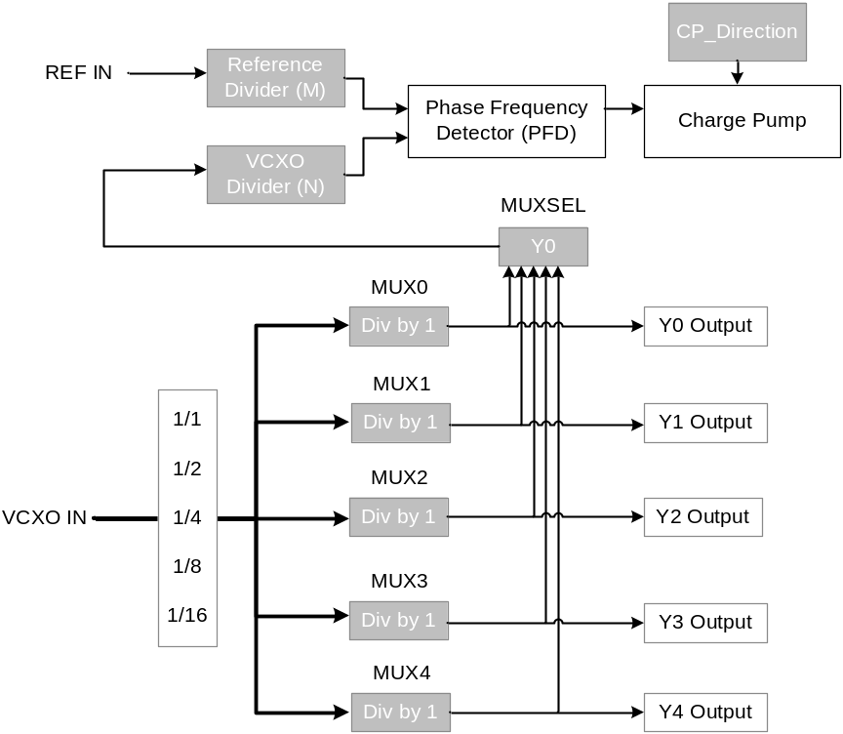
Figure 1.- Parameters of PLL Board.
The frequency of the two inputs of the PFD should be the same, and thus, the following formula should be maintained in order to be able to lock the PLL:
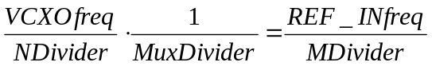
Equation 1.- Relation between PLL parameters and RF signals Frequency (Reference and VCXO)
The configuration parameters of the VCXO are also sent through custom register 10. These parameters should be sent just after initialization of the FMC Boards.
Parameter | value | Command to be sent through CLI to configure VCXO
M Divider (ref) | 1 | write 0x70000040 | 0x03E80000
N divider (VCXO) | 8 | write 0x70000040 | 0x03EA0007
MuxSel | 0 | write 0x70000040 | 0x03EC0000
Mux0 Divider | 0 | write 0x70000040 | 0x03EE0000
Mux1 Divider | 2 | write 0x70000040 | 0x03F00002
Mux2 Divider | 0 | write 0x70000040 | 0x03F20000
Mux3 Divider | 0 | write 0x70000040 | 0x03F40000
Mux4 Divider | 0 | write 0x70000040 | 0x03F60000
Send Word | 0 | write 0x70000040 | 0x03F80000
CP_Dir | 1 | write 0x70000040 | 0x03FA0001
VCXO Output inversion | 0 | write 0x70000040 | 0x03FC0000
Send Word | 1 | write 0x70000040 | 0x03F80001
Table 14.- VCXO parameters to be sent through custom register 10

FPGA program
The steps to run the CLI in the Linux Host PC and reprogram the FPGA are the following ones:
- Open a terminal in the Linux Host PC
- Browse to the CLI folder: /opt/Nutaq/ADP6/ADP_MicroTCA/sdk/bin
- Run the CLI script as super user: sudo ./adp_cli.py
- Establish connection with the Perseus Board with the command “connect” and the IP address of the board. Example: connect 192.168.0.101
- Reprogram the FPGA with the “fpgaflash” command. The arguments for this command are: Index (1 or 2), bit stream file path to flash and comment (optional) (this action may take several minutes): fpgaflash 1 “C:\download.bit” “This is my comment”
- Reboot the FPGA so the new program is loaded from the flash: reboot
- Exit the CLI script and open it again to establish connection with the Perseus boards.

FPGA version
One way to check if the FPGA has been well programmed is looking at the FPGA version code, which will be available in the “LLRF GUI” in the tab “FPGA version”.
This version code is composed of 10 digits, the first 4 correspond to the year of the code version, the following 2 correspond to the month, the following 2 to the day and the last 2 will be version number corresponding to that day.

RAM Initialization for Fast Data Logger
To initialize the RAM of the Fast Data Logger and send the stored data from the Perseus to the hosts, the commands shown in Error! Reference source not found. should be sent. The user should take into account that there are two stages for a “Fast Data Logger” Acquisition:
- Initialization of FDL memory buffer BEFORE Interlock Trigger or Acquisition on demand
- Data retrieval AFTER Interlock Trigger or Acquisition request
The default values shown in Table 15 are configured to retrieve 10ms of data after the interlock.
Commands to be sent to initialize RAM of Fast Data Logger BEFORE INTERLOCK
ram_init
recplay_record 25600000 1
Commands to be sent to initialize RAM of Fast Data Logger AFTER INTERLOCK
recplay_record_check_transfer_done 200
ram_get ../../bin/record.bin 0 25600000 1024 200
Table 15.- Commands for Fast Data Logger transfer from Perseus to Host

LLRF GUI
The expert LLRF GUI will be divided in five main parts, as depicted in Figure 2
- Start Menu
- Main Parameters
- Main Diagnostics
- Fast Interlocks: Parameters and Diagnostics
- Fast Data Logger Menu
All the parameters are defined for RF Chain A and RF Chain B and their behaviour are identical, although they can be set independently.
Following points will describe each part of the GUI and will show the addresses of each parameter/diagnostic signal for better comprehension.
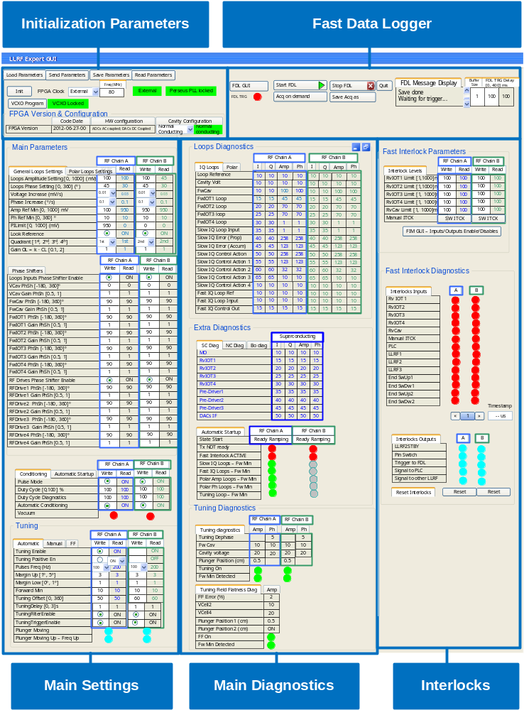
Figure 2.- Diamond SC Cavities LLRF Expert GUI

Start menu and Cavity Configuration

Initialization command
By pressing the button “init” of the GUI Start Menu (top left corner) depicted in Figure 3, the Device Server should send the initialization commands of the Perseus system. The initialization commands are described in Table 16, Table 17 and Table 18.
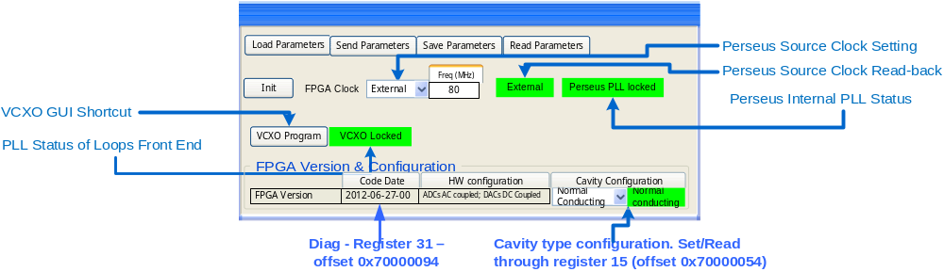
Figure 3.-Start Menu and Cavity Configuration
Initialization commands of Perseus Boards | Comments
custom_register_write 4 1  mo1000_powerup 1  mo1000_reset 1  mo1000_init 1  mo1000_setdacparinterpolation 1 1x  mo1000_dodacupdate 1  mo1000_setclockconfig 1 Ext 80000000 80000000 Manual 80000000  mo1000_writeclockconfig 1  mo1000_dodaccalibration 1  mo1000_setdacoutctrl 1 1 Enable  mo1000_setdacoutctrl 1 2 Enable  mo1000_setdacoutctrl 1 3 Enable  mo1000_setdacoutctrl 1 4 Enable  mo1000_setdacoutctrl 1 5 Enable  mo1000_setdacoutctrl 1 6 Enable  mo1000_setdacoutctrl 1 7 Enable  mo1000_setdacoutctrl 1 8 Enable  mo1000_gettemperature 1 temp1c  mi125_powerup 2  mi125_reset 2  mi125_set_clksrc 2 BOTTOMFMC  mi125_get_temperature 2 TEMP1C  custom_register_write 4 0 | Command to reset Asyn FIFO of DACs  Clock source: External and set to 80MHz  Removal of reset of async FIFO of DACs
Table 16.- Initialization commands of MO1000 and MI125
Commands to Configure GPIO Bus for Perseus Board
Command | Comment
write 0x7000004C 0x1 | Reset
write 0x7000004C 0x0 | Reset removed
write 0x7000004C 0x1ffff | Direction of 16LSBs of GPIO as inputs
write 0x7000004C 0x20000 | Direction of 16MSBs of GPIO as outputs
write 0x7000004C 0x30001 | Send direction settings of GPIO bus
write 0x7000004C 0x30000
write 0x7000004C 0x40001 | Synchronization of GPIO bus
write 0x7000004C 0x40000
Table 17.- Initialization commands for GPIO Bus
Parameter | value | Command to be sent through CLI to configure VCXO
M Divider (ref) | 1 | write 0x70000040 | 0x03E80000
N divider (VCXO) | 8 | write 0x70000040 | 0x03EA0007
MuxSel | 0 | write 0x70000040 | 0x03EC0000
Mux0 Divider | 0 | write 0x70000040 | 0x03EE0000
Mux1 Divider | 2 | write 0x70000040 | 0x03F00002
Mux2 Divider | 0 | write 0x70000040 | 0x03F20000
Mux3 Divider | 0 | write 0x70000040 | 0x03F40000
Mux4 Divider | 0 | write 0x70000040 | 0x03F60000
Send Word | 0 | write 0x70000040 | 0x03F80000
CP_Dir | 1 | write 0x70000040 | 0x03FA0001
VCXO Output inversion | 0 | write 0x70000040 | 0x03FC0000
Send Word | 1 | write 0x70000040 | 0x03F80001
Table 18.- Initialization commands for VCXO (default values assuming freq of Ref Signal = MO/50)

Clock configuration
By default, the Perseus boards will work with an external 80MHz clock. This is specified in the “initialization” process by the following command:
- mo1000_setclockconfig 1 Ext 80000000 80000000 Manual 80000000
The system could also work with an internal clock and different frequency when no external clock is available. The “Perseus Source Clock Setting” of the GUI will define if the source clock is “internal” or “external”. The “Freq” parameter of the GUI displayed in Figure 3 will define the frequency of the internal clock in MHz. These two settings, source clock and frequency, should be defined using the “mo1000_setclockconfig” command.
After changing the frequency or clock source of the Perseus, the user should press the “init” button to reconfigure the HW with the new settings specified by the user in the GUI.

FPGA Version and Cavity Confguration
The FPGA Version should also be displayed in the “Start menu” of the GUI together with the cavity configuration. The FPGA version is read in register 31 (offset 0x70000094) and the cavity type is set through register 15 (offset 0x70000054).

VCXO Configuration
The “VCXO Program” button shown in Figure 3 should open the GUI displayed in Figure 4.
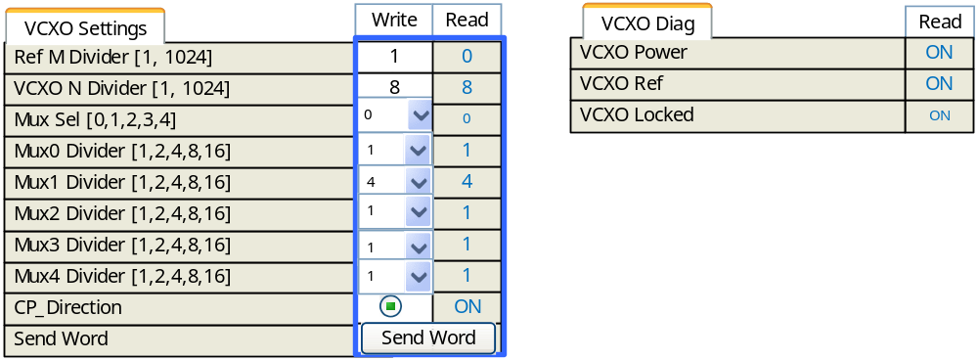
Figure 4.- VCXO GUI – Settings and Diagnostic
The initialization process should send the default parameters of the VCXO, which are displayed in Table 18, but the user may change those if needed. The “init” button should be pressed in case the frequency of the VCXO is changed.
Figure 5 shows the addresses of the settings and diagnostics signals related to the VCXO. The settings should be written through register 10. The read-back of the setting should be read through register 11 and the diagnostics signals should be read through register 12.
The settings from address 502 to 507 are defined in the “Nutaq registers calculation for Diamond LLRF.xls” as enumeration type. This implies that only certain values should be set through this register. In this case, we recommend to implement those settings in the GUI using combo-boxes with the pre-defined allowed values, as shown in Figure 5.
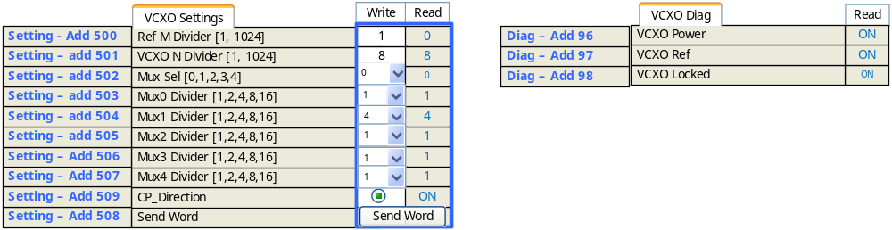
Figure 5.- Addresses of VCXO settings and diagnostic signals

Save, Load and Send Parameters buttons
When a stable configuration of the LLRF has been found, the settings of the LLRF may be saved in an .xml file or similar by pressing the button “save” of the start menu. This file could be uploaded in the GUI by pressing the button “load” and send to the FPGA by pressing the button “send”.

Main Settings

Loops Settings
The Loops Settings will have four different tabs:
- General loops Settings
- IQ or Rectangular Loops Settings
- Polar Loops Settings
- Ramping Settings for Booster

General Loop Settings
Figure 6 shows the general amplitude and phase loop settings and their addresses. In this case, the settings should be written through register 10 for Cavity A and through register 20 for Cavity B. The read-back of the settings of Cavity A should be done through register 11 and through register 21 for Cavity B.
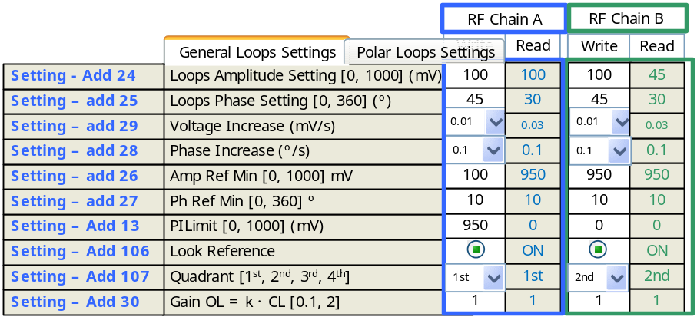
Figure 6.- General Amp&Ph Settings
The settings defined as “enumeration” in the “Nutaq registers calculation for Diamond LLRF.xls” excel file have been represented in the GUI as “combo-boxes”. The user should select which an option from the combo-box and the GUI/DS should translate this into the number to be sent to the corresponding register.

Rectangular or IQ loops settings
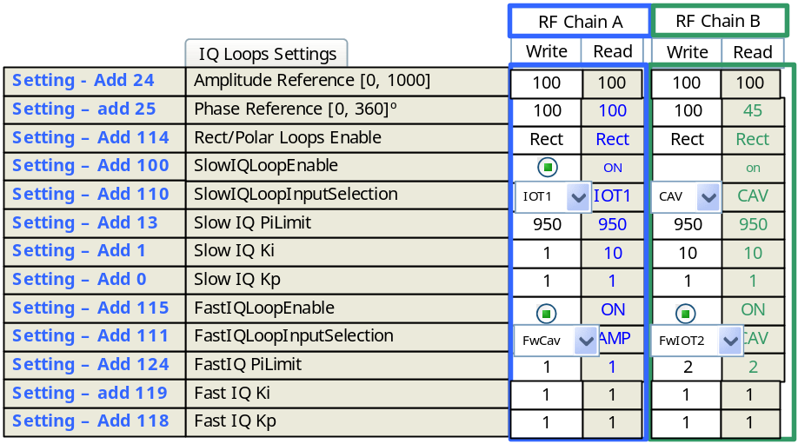
Figure 7.- Rectangular or IQ loops settings

Polar Loops Settings
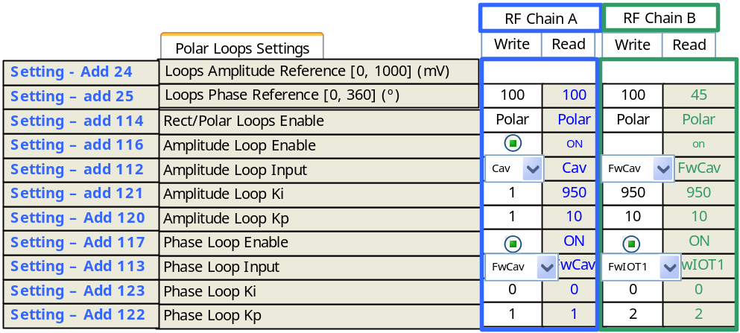
Figure 8.- Polar Loops Settings

Ramping Settings for Booster Cavity
The settings of this tab will only be considered when the Booster Cavity Configuration is selected.
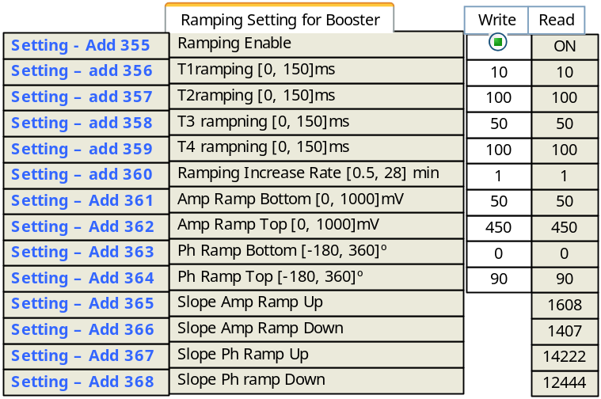
Figure 9.- Booster Ramping Settings
Take into account that the settings “slope XXXX” from addresses 365 to 368 should be calculated by the Device Server taking into account the settings “Amp Ramp Bottom & Top”, “Ph Ramp Bottom&Top” and “TxRamping”. For this reason the “write field” of those parameters are not enabled, but the “read-back” field is displayed in the GUI.

Phase Shifter Settings
Below the general loop settings, there will be a tab to apply phase shifters to Loops Inputs and Loops Outputs as shown in Figure 10
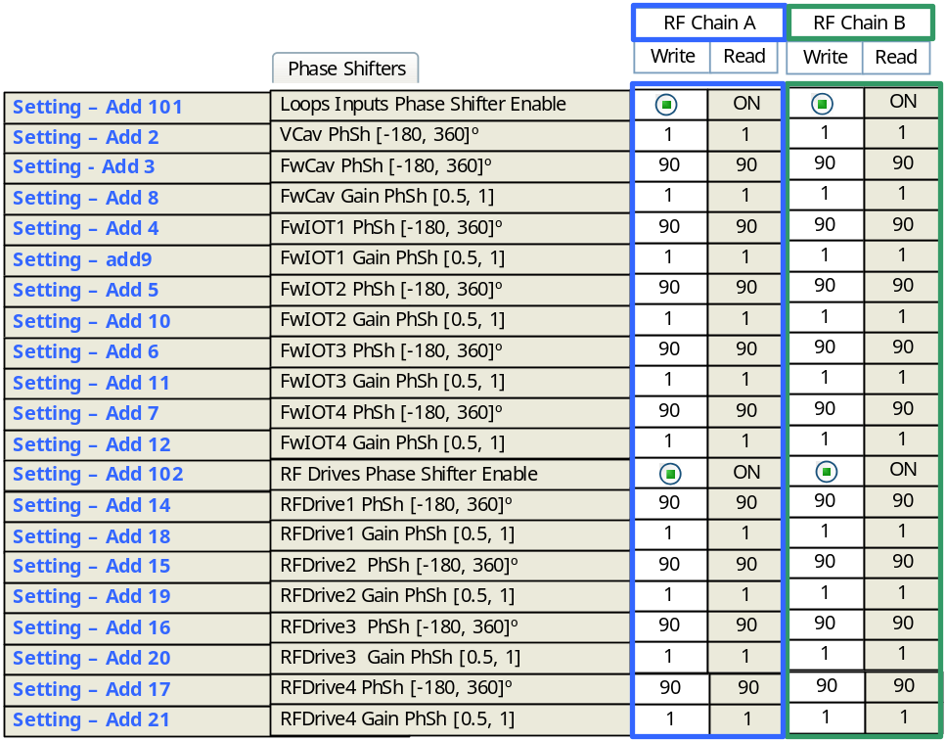
Figure 10.- Phase Shifters settings

Special operation modes
The “automatic Start-Up” settings and “conditioning” settings tab will be below the phase shifters, as shown in Figure 11 and Figure 12

Automatic Start-up
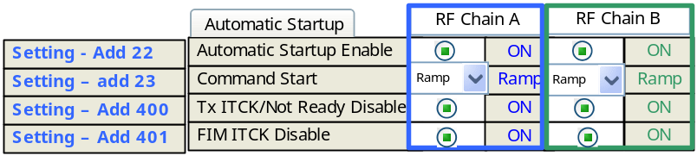
Figure 11.- Automatic start-up

Conditioning Mode operation
There are two diagnostics signals in the Settings Conditioning tab: “Duty cycle diagnostics” and “Vacuum”. In these two cases the “write” field for these two signals is not enabled.
Besides, the “vacuum” diagnostic signal with address 79 should be represented by a “red” led when it is equal to ‘1’ and by an “off” led when it is equal to ‘0’.
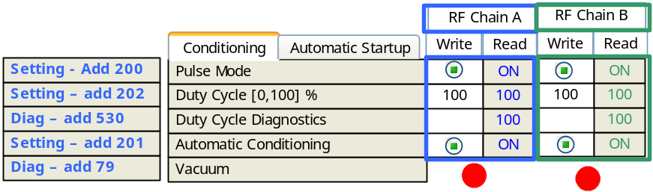
Figure 12.- Conditioning mode settings

FIM Settings
The settings of the Fast Interlock Module (FIM) will consist basically on defining the limits for the reverse power of some RF signals
The “manual itck” setting (address 805) should be set to ‘1’ and then should be set to ‘0’ when the user presses the button “SW ITCK” displayed in Figure 13.
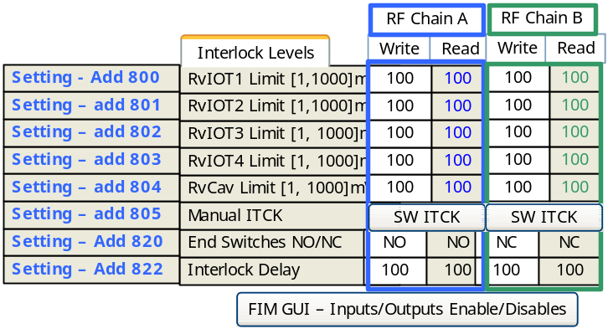
Figure 13.- FIM settings
When pressing the button “FIM GUI – Inpust/Outputs Enable/Disables” shown in Figure 13, the GUI shown in Figure 14 should appear.
In overall there are 14 interlock inputs and 6 interlock outputs. Each interlock input can trigger every interlock output independently. Figure 14 shows which interlock output should get triggered or disabled by each interlock input.
The setting with address 806 is used to enable/disable the interlock outputs associated with the first interlock input, which is RvIOT1. By default, the 6 bits of address 806 should be ‘0’ to enable the associated outputs of “RvIOT1” interlock. In case one or all of these interlocks outputs has to be disabled, the corresponding bit of that address should be set to ‘1’, as shown in Figure 14.
The same configuration should be applied to the other interlocks inputs (addresses from 807 to 819).
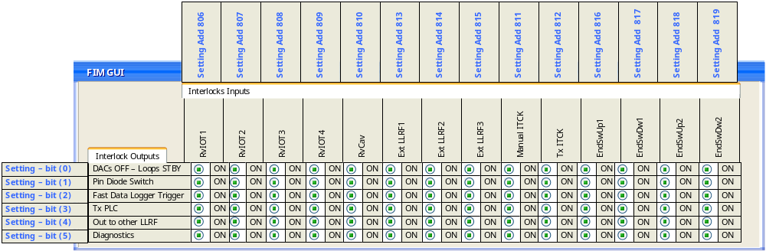
Figure 14.- Inputs/Outputs Enables/Disables of FIM

Diagnostics
The main diagnostics of the loops will be displayed by two tabs:
- IQ or Rectangular Loops Diagnostics
- Polar Loops diagnostics

IQ or Rectangular loops diagnostics
For each diagnostic signal four values are shown in these tabs:
- I coordinate
- Q coordinate
- Amplitude
- Phase
Usually, the FPGA just calculates the I&Q coordinates of each RF signal. The calculation of the amplitude and phase should be done by the Device Server and displayed in the GUI, according to Equation 2:
$$Amp= \sqrt{I^{2}+Q^{2}}$$
$$Ph=\operatorname{atan}\left(\frac{Q}{I}\right)$$
Equation 2.- Rectangular to polar conversion
The addresses displayed next to each diagnostic signal in Figure 15 correspond to the addresses of the I&Q coordinates.
Besides, some of these diagnostics signals will be available only for some cavity type configurations, but not all as shown in Figure 15.
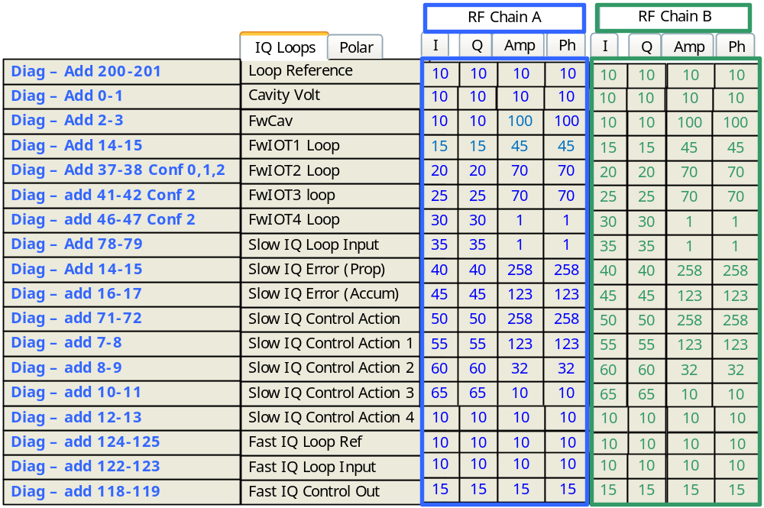
Figure 15.- Diagnostics of IQ loops

Polar Loops Diagnostics
The polar loops diagnostic signals also are composed by four elements per signal:
- I coordinate
- Q coordinate
- Amplitude
- Phase
In most of the cases, the FPGA just provides the I&Q coordinates, but in some cases, like “Polar Loops control”, “AmpLoopInput” and “PhaseLoopInput”, the corresponding amplitude and phase values are also calculated by the FPGA. In these cases, four addresses will be displayed next to the corresponding signal as shown in Figure 16.
Besides, the I&Q coordinates of “Polar Loops Error” and “Polar Loops Accum Error” are not computed by the FPGA. For this reason they are not displayed in the GUI as shown in Figure 16. The addresses next to these two signals correspond to the amplitude and phase components.
Last, there are some diagnostic signals like FwIOT3&4 only available for configuration 2 as shown in Figure 16.
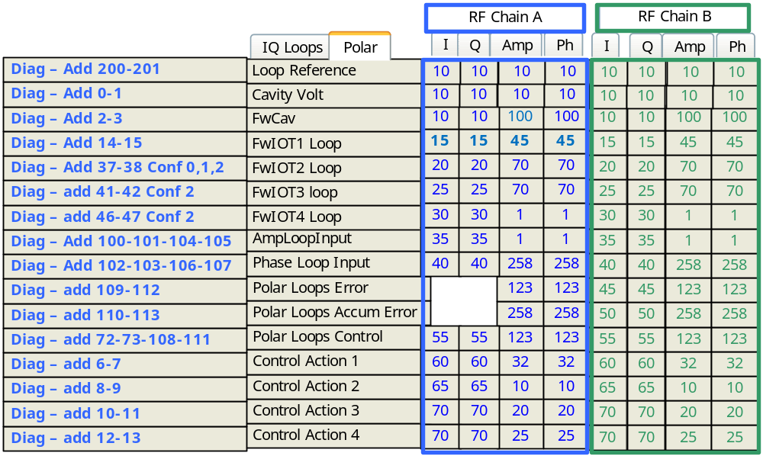
Figure 16.- Polar Loops Diagnostic

Extra RF diagnostics
Besides the signals involved in amplitude and phase control loops, there are some other RF signals monitored by the LLRF. Depending on the cavity configuration type, these diagnostic signals will be shown in three different tabs:
- Super conducting cavity extra diagnostic
- Normal conducting cavity extra diagnostic
- Booster cavity extra diagnostic

Super conducting cavity extra diagnostic
When the LLRF is configured to control a superconducting cavity, it will be able to control just one cavity and not two. For this reason, the diagnostic signals corresponding to cavity B have not been displayed in Figure 17.
Usually, the FPGA only provides the I&Q coordinates of each signal. The addresses corresponding to these coordinates are shown next to each signal in Figure 17. The Amplitude and Phase values of each signal should be calculated by the DS. However, the FPGA does compute the I&Q coordinates + the Amp&Ph values of the “DACs IF” signal. For this reason four addresses have been added in that signal in Figure 17, the ones corresponding to the I&Q values and the addresses corresponding to Amp&Ph.
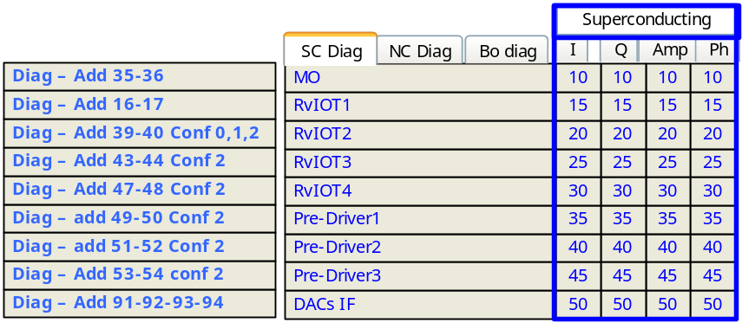
Figure 17.- Superconducting cavity diagnostic

Normal conducting cavities extra diagnostic
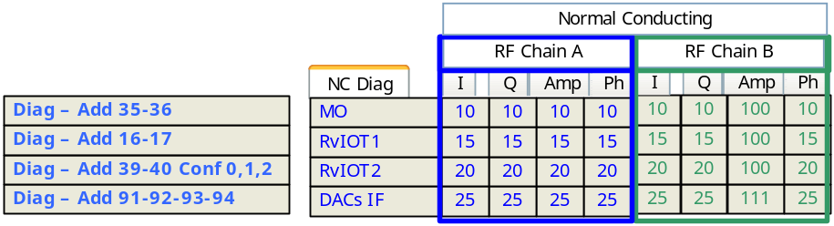
Figure 18.- Normal conducting cavities extra diagnostic

Booster cavity extra diagnostic
In the booster case, besides the “standard” extra diagnostic signals displayed in Figure 19, the FPGA will show the values of the RF signals at the bottom of the ramp and at the top of the ramp, as shown in Figure 20. The diagnostic signal “TuningDephase” does not have I&Q or amplitude values. For this reason those fields are removed from the GUI. The “FFError” only has “amplitude” value, but not I nor Q nor phase value, as shown in Figure 20.
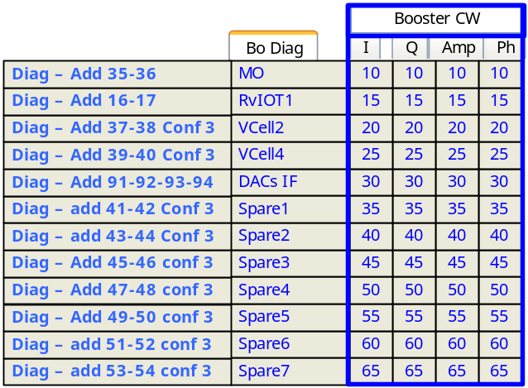
Figure 19.- Booster cavity - Extra diagnostic in CW
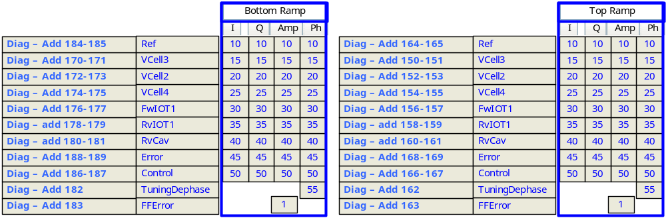
Figure 20.- Booster Cavity - Ramping Diagnostic

Automatic Start-up diagnostic
The tab for the automatic start-up diagnostic is mainly composed of leds. Signals “Tx not ready” (add 400) and signal “Fast interlock active” (add 401) should be represented by a red led when their values are ‘1’ and they should be represented by an “OFF” led when their values are ‘0’.
Signals “FwMin” from 307 to 311 address should be represented by a green led when their values are ‘1’ and by an “OFF” led when their values are ‘0’ as shown in Figure 21.
Signal “State Start” with address 500 should be transformed by the GUI or Device Server from an integer to a string as specified in “Nutaq registers calculation for Diamond LLRF.xls” file.
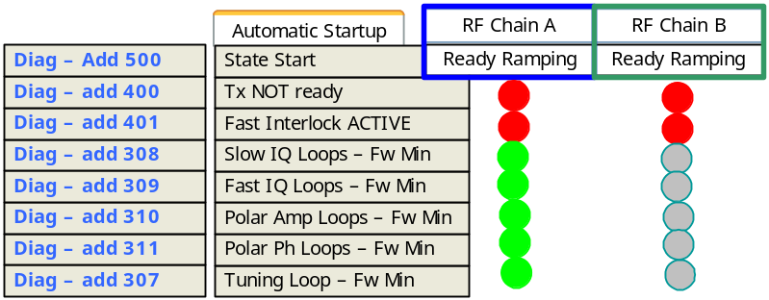
Figure 21.- Automatic Startup diagnostic

Tuning and Field Flatness Diagnostics
Figure 22 shows the diagnostics of the tuning and field flatness loop. The field flatness loop will only be used in the Booster cavity case.
In this part of the GUI the position of the cavity plungers have been included. This information should be provided by an encoder and it will not be available in the FPGA code. It has been added to this GUI as reference.
The signals “Tuning On”, “FwMin Detected” and “FFOn” should be represented by green leds when their values are ‘1’ and they should be represented by “off” leds when their values are ‘0’.
Take into account that in this part of GUI the I&Q components of the RF signals are not displayed, but only the amplitude and phases.
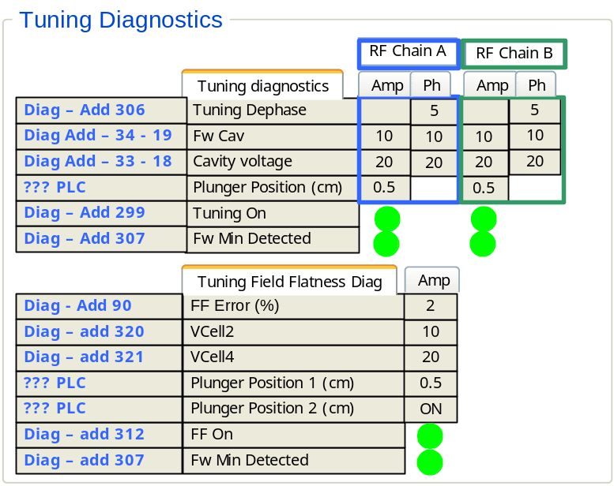
Figure 22.- Tuning and Field Flatness diagnostics

FIM Diagnostics

Interlock inputs
There are 14 interlock inputs controlled by the FIM utility. Whenever an interlock is detected, it gets registered in diagnostic signal with address 451. Each of the 14 bits of this address corresponds to the status of the 14 interlock inputs. In case the value of these interlocks changes later on, the new interlock status will get recorded in the 14 bits of the following address (452). The time elapsed between two consecutive interlocks will be recorded in addresses from 458 and 464. If the interlock status changes again, the new interlock state will be recorded in address 453 and so on up to 7 different interlock sequences.
The user should be able to select which interlock has to be displayed in the GUI (first interlock, second interlock, etc). In Figure 23 the first interlock was selected. In that case, the information contained in diag address 451 should be displayed. In case any of the 14 bits of this address is set to ‘1’, the adjacent led should be red. If the value of those bits is equal to ‘0’, then the adjacent led should be “OFF”.
Also the “timestamp” diagnostic signal with address 458 for interlock 1 should be displayed as shown in Figure 23
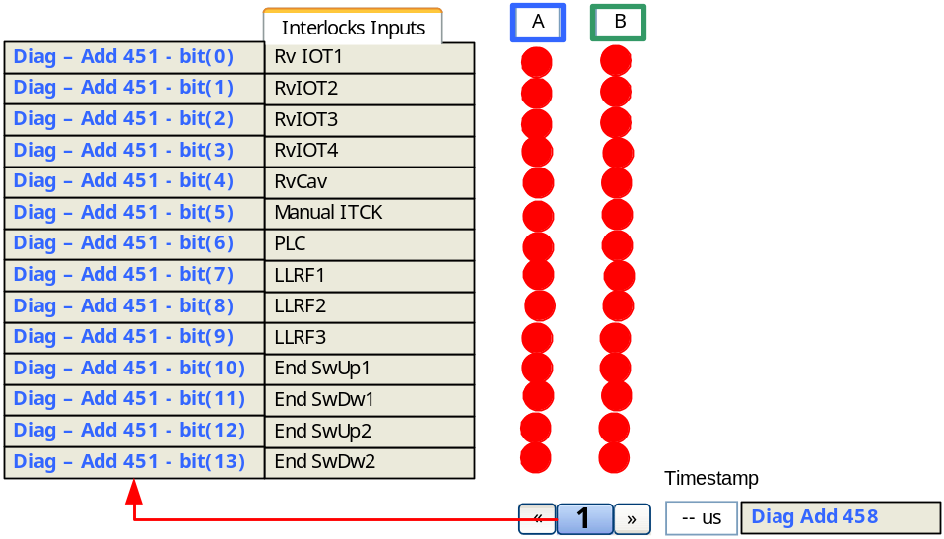
Figure 23.- Interlock inputs diagnostics
Figure 24 shows the data that should be displayed by the GUI in case the user selects to see the 2nd interlock detected. In this case, the bits of address 452 should be shown and the “time stamp” signal should show the value stored in address 459.
Figure 25 shows the information related to the third interlock detected. The GUI should be able to display up to 7 different interlock sequences, i. e. up to address 457.
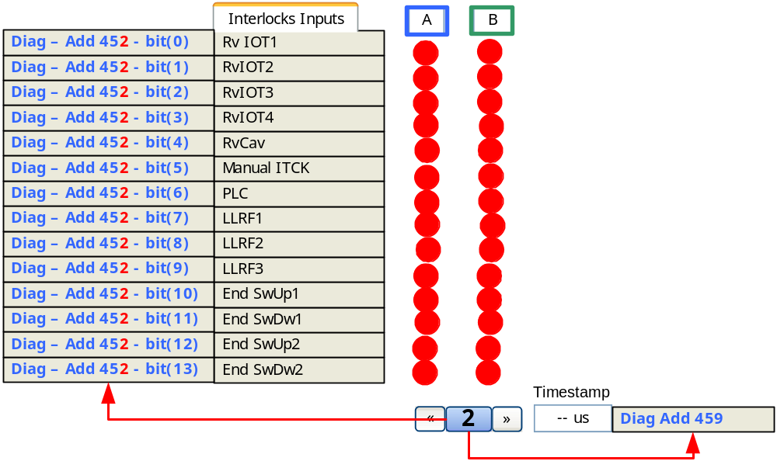
Figure 24.- 2nd Interlock detected by FIM
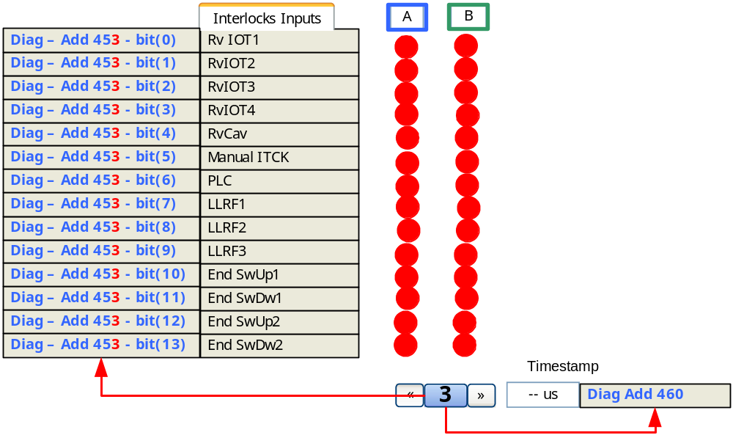
Figure 25.- 3rd Interlock detected by FIM

Interlocks outputs
Figure 26 shows the interlock outputs generated by the FIM. This information can be read from diagnostic address 467. Each bit of this register corresponds to a different interlock output as shown in Figure 26.
In order to reset the interlock inputs and outputs the user should press the “reset” button shown in Figure 26. When doing this, the DS should write a ‘1’ in setting address 821 and then write a ‘0’ in the same address.
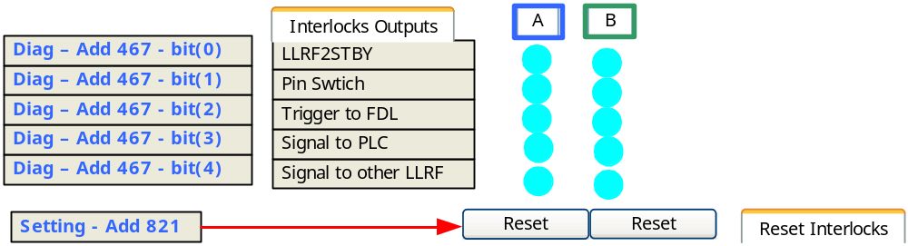
Figure 26.- Interlock outputs diagnostic

Fast Data Logger (TBD)

Note that the path of the Command Line Interface (CLI) python script may vary depending on the version of the Perseus Drivers.
For more information on this board refer to texas instruments webpage: www.ti.com
Note that the path of the Command Line Interface (CLI) python script may vary depending on the version of the Perseus Drivers.

